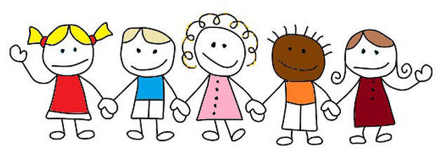
About My Child:
Child’s Name:______________________________________________
Mother(Guardian):____________________________________________
Father (Guardian):_____________________________________________
Marital Status:_________________________________________________

Siblings: Name Age
_________________ ______________
_________________ _______________

What foods does your child like/dislike? _____________________________________________
Favorite games or activities?_______________________________________________________
Favorite book?__________________________________________________________________
Is your child potty trained?________________________________________________________
How does your child express anger or frustration?_____________________________________
When your child is upset, what helps to comfort him/her?_______________________________
Language spoken at home?________________________________________________________
Does he/she have a special toy or blanket for nap?_____________________________________
Any disorders/developmental (delayed/advanced)diagnosed or suspected?_____________________________________________________________________
Has he/she attended a child care center before?_______________________________________
Anything else you would like us to know?_______________________________________________________________________

